Lab 8 Stellar Spectra

Goals
- Learn how stars are classified ( O B A F G K M ) and what these types represent about temperature
- Examine the relationship between temperature of an object and the spectrum it produces
- Examine 8 real stellar spectra and determine the spectral type of the stars

Resources
PhET Thermal spectrum simulation https://phet.colorado.edu/en/simulation/blackbody-spectrum
The Astrophysics Data System (ADS) http://adsabs.harvard.edu/abstract_service.html

Background Knowledge
Recall that there are three types of spectra: Thermal (continuous), emission line, and absorption line. Here we will focus on the thermal spectrum from stars which also contain absorption lines. The overall shape of the spectrum will tell you about the temperature, and the absorption lines will tell you about the chemical composition and ionization state of the outer layers of the star’s atmosphere. The combination of absorption lines and temperature provide a way to classify stars based on their temperature.

Spectral Type | Temperature range [K] | Absorption lines
O | Hotter than 30,000 | He+, O++, N++, Si++, He, H
B | 30,000 – 10,000 | He, H, O+, C+, N+, Si+
A | 10,000 – 7,500 | H (strongest), Ca+, Mg+, Fe+
F | 7,500 – 6,000 | H, Ca+, ionized metals
G | 6,000 – 5,000 | H, Ca+, ionized and neutral metals
K | 5,000 – 3,500 | H (weak), Ca+ (strongest), neutral metals
M | Cooler than 3500 | Neutral metals, TiO, molecules

(Note: Each Spectral Type is subdivided from 0-9 as well. E.g. the Sun is a G2 spectral type.
... F0, F1, F2, ….,F8, F9, G0, G1, G2, G3, G4, G5, G6, G7, G8, G9, K0, K1, K2….. etc… )

Part 1 : Temperature and peak wavelength of emission

Think About It
A blackbody is a solid or a very dense gas. In the case of a traditional light bulb, the blackbody is the filament, a solid. As you increase the power to the light bulb, what happens to the temperature of the filament?
An increase in power to the light bulb means increasing the voltage of the bulb. We know that the resistance of a bulb is not constant. Now any increase in power will lead to an increased current of a bulb and this makes the bulb to get hot hence making the filament to glow.

What happened to the color of the filament?
With increase in voltage, the temperature of both bulb and filament also increases making the color as well as the light intensity to change. When the temperature of the filaments increased, the color of the filament changed in three ways. It first changed to red, from red to yellow and finally from yellow to white.

What is the relationship between the temperature of the filament and the wavelength of the color of the filament?
Considering temperature and wavelength of the color filament there is a notable relationship. For instance, the increase in temperature of the filament within tungsten-Halgen lamb there is a shift in light emission profile. The shift goes to short wavelength such that, the temperature tends towards limiting tungsten melting point. This intern makes wave length emitted by lamb to substantially increase.
Work On It
Use a spectrograph or grating slide to observe a light bulb connected to a variable power source. Vary the power going from lowest 1.0V to highest 8V and record what you see in the spectrograph.

Think About It
When the bulb was receiving the lowest power, was there blue light? When the bulb was receiving the highest power, was there red light? Did the spectrum you observed change as you changed the power going to the light bulb? How did it change, if it did? If it didn’t change, why do you think it did not change? Do your best to explain your observations based on what you know. Check your explanations with your instructor.

Work on it
Use the blackbody radiation simulation found at the PhET website in the resources.


The red curve represents the thermal spectrum produced by an object of the given temperature. Vary the temperature from a low of 3,000K to a high of 9,255K. Note the relative height of the curve and the position of the peak, where the most light comes out.

Temperature [K] | Relative height of curve | Peak wavelength
3000 | 3.13 | 0.966
4000 | 13.18 | 0.724
5000 | 40.21 | 0.580
6000 | 100.06 | 0.483
9255 | 871.39 | 0.313
(Note, you may need to change the scale of the vertical axis if the peak goes off the chart.)
You should find that as temperature increases, the overall amount of emission increases, and the peak moves to shorter wavelengths. The relationship between temperature, T, and the peak wavelength of emission, λ_{max} , is given by Wein’s Law as follows.

$$T= \frac{2.9×{10}^{6} nm K}{λ_{max}}$$
T=$$T= \frac{2.9×{10}^{6} 0.966}{λ_{max}}$$

This relationship makes it possible to observe a spectrum, measure the peak wavelength of emission in units of nanometers, and then calculate the temperature of the object in Kelvin (no thermometer needed).

PART 2: Identifying stellar spectra

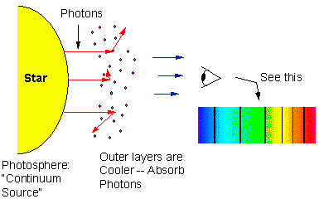
Think About It
Why do stars produce absorption line spectra? The interior of the star is very hot and dense, so it produces a continuous thermal spectrum. The outer layers of the star’s atmosphere are much lower density gas which the continuous light must pass through to reach us.
A stellar spectrum can be useful both to learn about the elements in the stars as well as its temperature. You can see below that a comparison of an ideal thermal spectrum to an actual absorption line spectrum from a star are very similar to each other. The overall shape of the spectrum can still be used to estimate λ_{max} and thus determine the temperature of the star.

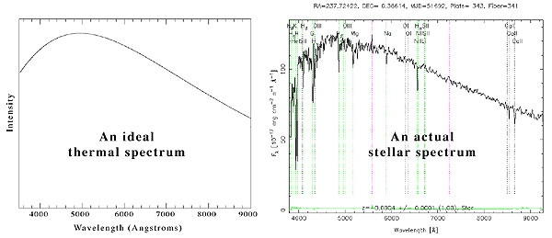

Understanding the details of absorption lines in stellar spectra can be quite complex, so we will use several comparison spectra to help identify the stellar spectra at the end of the lab. The Astrophysics Data System (ADS) is a resource that houses electronically scanned refereed publications in astronomy (http://adsabs.harvard.edu/abstract_service.html), where you can download and save or print out comparison spectra. Find the article written by Jacoby, Hunter and Christian in 1984, published in the Astrophysical Journal Supplement (ApJS). You can do this by typing in “Jacoby”, “Hunter” and “Christian” in the box under “Authors” and “1984” in the “Publication Date” box, then “Send Query”. The article is titled “A Library of Stellar Spectra.” To view the article, click on the “F” to view a .pdf file, which you should be able to page through and print. The spectra that you are interested in begin on page 259 of this article.

Work On It

Examine the 8 stellar spectra at the end of this lab. Use what you know about Wein’s law to determine the temperature of the stars (or place limits on it).
Based on the Wien’s law, temperature of stars can be determined by considering the temperature of blackbody radiation. As this radiation increases it means that, increase in the peak of radiation curve. Now, considering the wavelength of peak of blackbody radiation curve we get the temperature of the star. For example, see the figure below
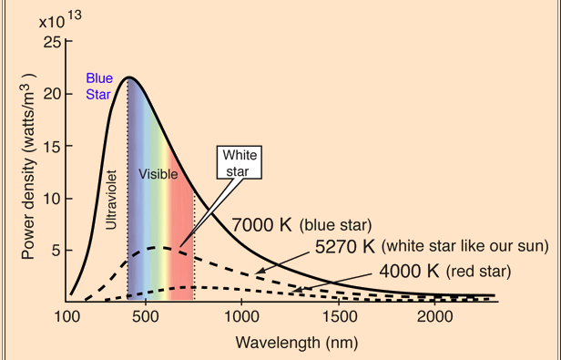
Let’s consider white star. Realize that it is adjusted to around 5270K and he blackbody curve of its peak is at wavelength of 550nm. Therefore, we can deduce that the temperature of the star (white star) is 5270K based on its peak.
Compare the spectra to the reference spectra from the article and examine their absorption line features.
From the article, O spectral type has an ionized helium spectral Line. B spectral type has some hydrogen and Helium spectral absorption line. A spectral type has a strong hydrogen absorption lines with some ionized metals. F spectral type’s absorption is that of Hydrogen and ionized calcium.

Lab Report
Introduction
Explain the Stellar Spectral Types and what they represent about the physical properties of a star
Steller spectral types comprises of are stars that are currently classified MK system where letters O, B, A, F, G, K, and M are used. They are arranged in a sequence from hottest to coolest type. These stars are classified based on their spectra as well as their temperature.
The stellar spectral types represent about brightness, color, surface temperature and size about physical characteristics of a star. O type star is blue in color with an average radius of 15, mass of 60 and surface temperature of over 25, 000 K. B star type is blue in color with average mass of over 11,000 but not more than 25,000 K. A star type is blue in color with a mass of 3.2. Its surface temperature is between 7,500-11,000 K. F star type is blue to white with a surface temperature of 6000-7,500K and mass of 1.7. G type is white to blue its surface temperature of 5000-6000k and mass and radius of 1.1.k-star type is orange to red and its surface temperature is 3,500- 5000K with a mass of 0.8. Finally, we have M star type that has a surface below 3,500 k and a mass of 0.3. its luminosity is very faint.
Explain what Wein’s law represents and how it is useful for your goal of identifying spectral types
The wien’s law represents ways of determining star’s temperature based on hotter and cooler objects. It is meant to express emission of radiation at both high and low frequencies. It also represents how spectra are emitted at different temperatures at different peak wavelengths.
The wein’s law is important in identifying spectral type in that it uses the principle shifting at the pick and describes how brightness of a spectra’s body radiation depends on wavelength and temperature. This knowledge is very important in identification of spectral types.

Methods
In the graphs I am interested in looking at Blackbody temperature, wave length and spectral power density. I am also looking finding out the existing relationship and interaction between wavelength and spectral power density. I will use computation such as determination of wavelength and spectral power density, determination of Lumosity and temperatures. I will compare the impacts of temperature on different spectral types and examine what determine different shapes of curves and different wave length.
Data
In a number of spectral types, a couple of features were identified. First in spectral type, I identified absorption lines. These lines were for neutral metallic ions and atoms. For instance, there was ionized calcium which grew in terms of strength. In K spectral type, I identified metallic lines that dominated the graph. They represented weak and blue continuum. The other specific feature was molecular bands of titanium oxide.

Conclusion
Star 3 is showing Spectrum: G5IV Star with an absorption line of reduced identity. It is mostly seen in stars that contains hydrogen that absorbs light from blackbody spectrum. Star 2 is type c star commonly known as carbon stars. It has deep red appearance when viewed by use of a telescope.

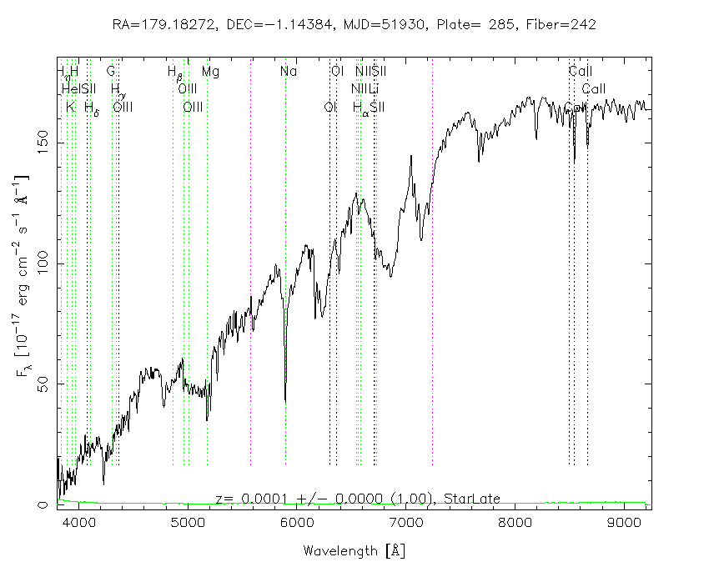
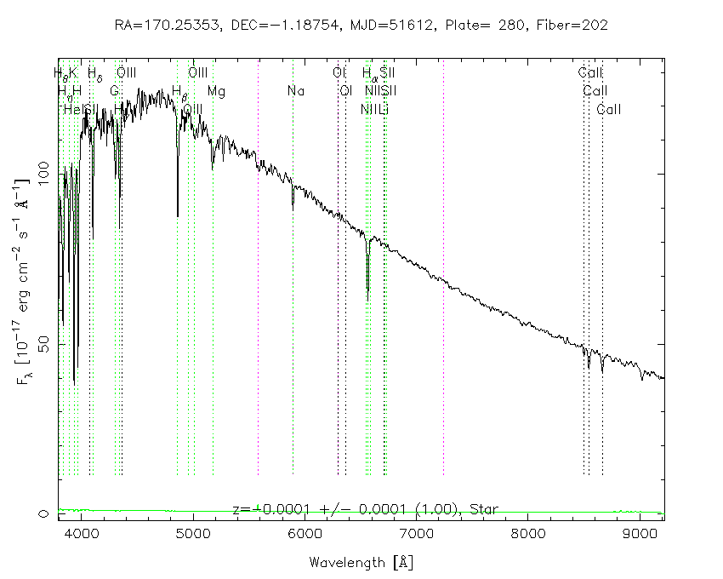
ASTRONOMY LAB: Stellar Spectra Identification
Star 1 Star 2
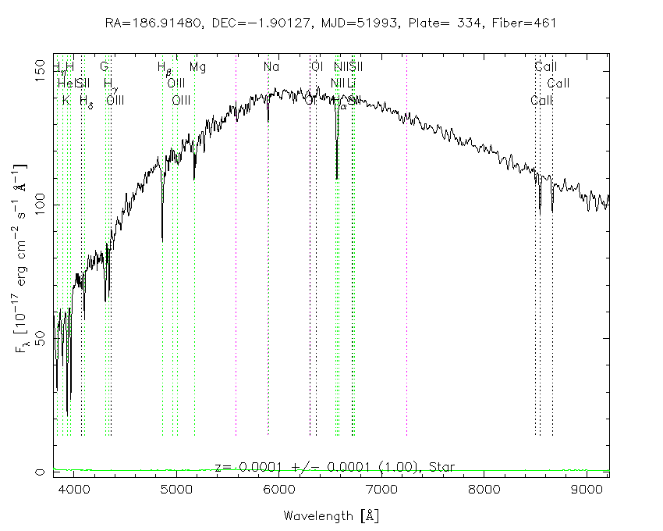
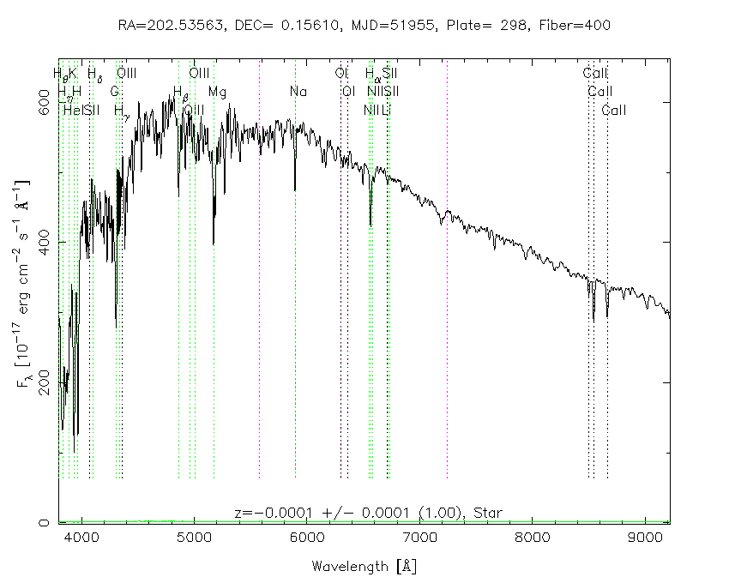
Star 3 Star 4

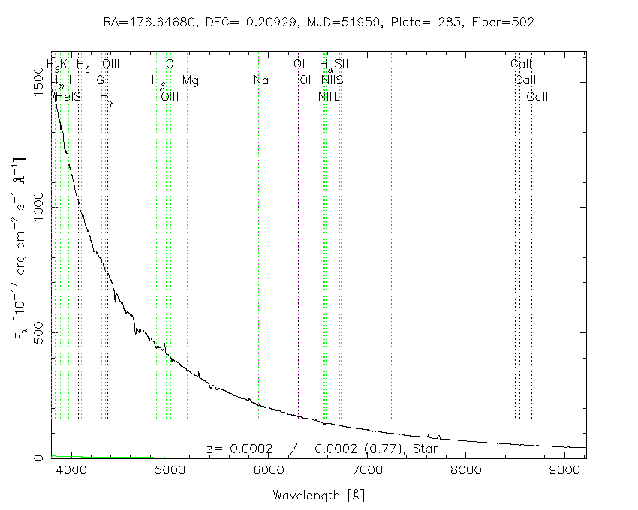
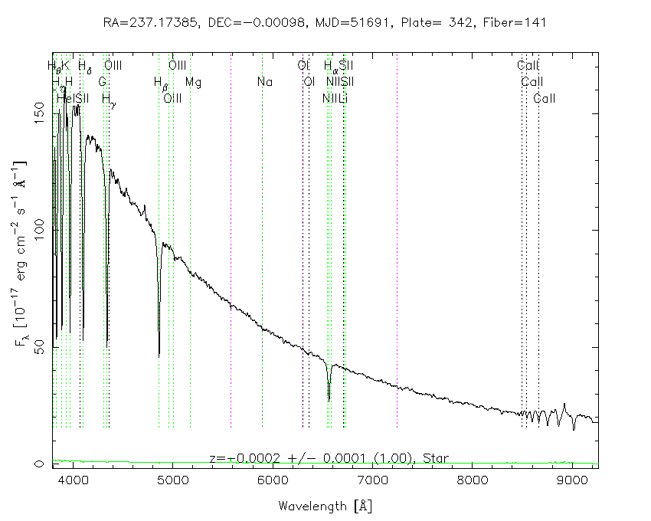
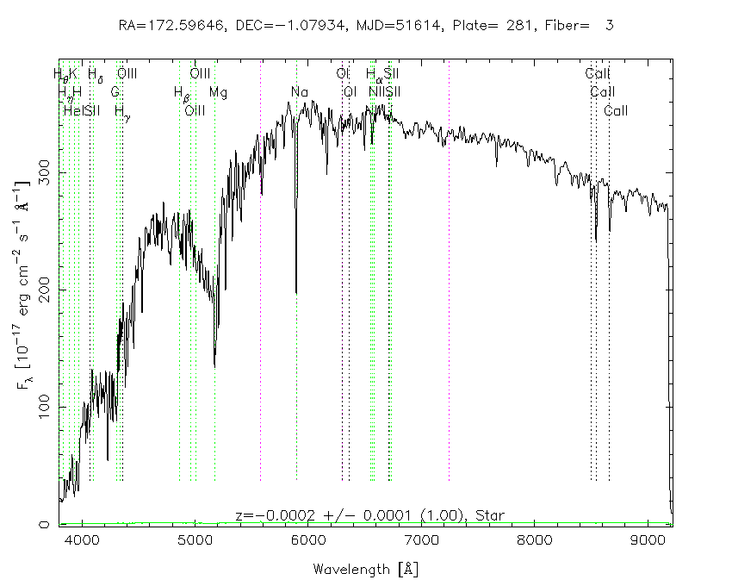
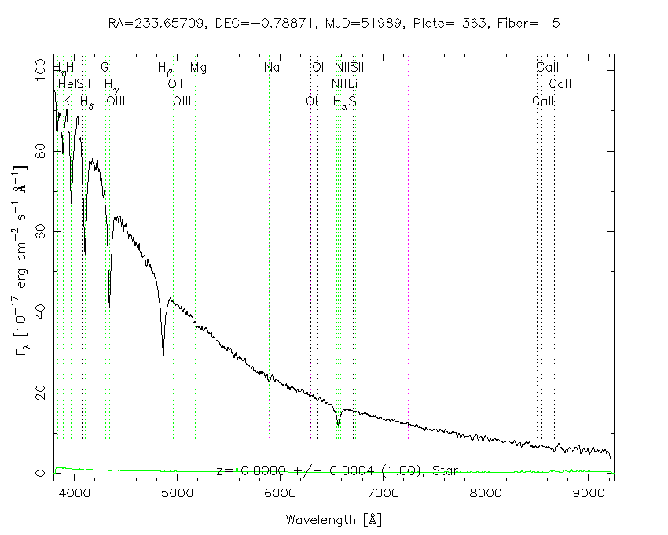
Star 5 Star 6
Star 7 Star 8

